LAB 3

HRITIK AJAY BANSAL

CSE A 15

180905105

Q1) x=int(input("enter no a "))

y=int(input("enter second no "))

print("1. add \n2.sub \n3. multi \n4. div")

z=int(input('enter choice '))

if(z==1):

print("addition = ",x+y)

elif(z==2):

print("subtraction: ",x-y)

elif(z==3):

print("multiplication: ",x*y)

else:

print("division: ",x/y)

output:

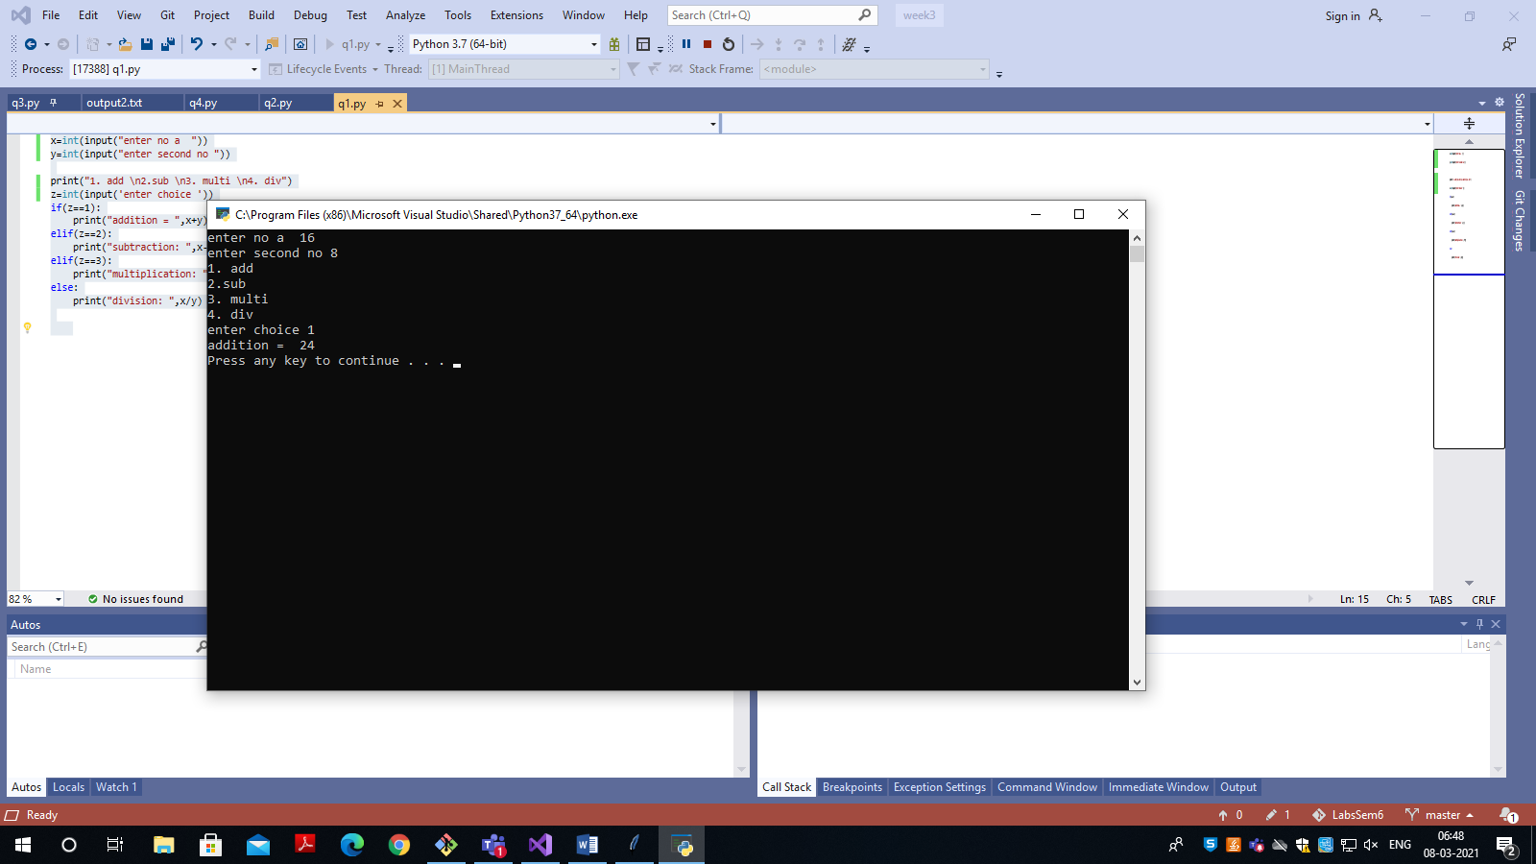 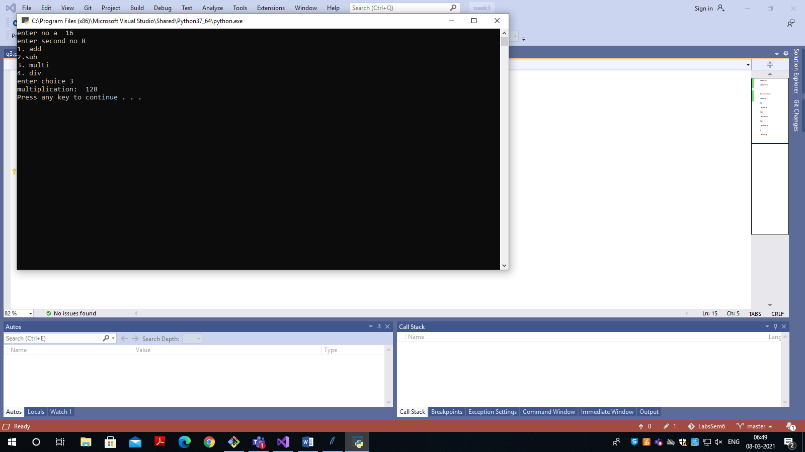

Q2) out= open("output2.txt", "w")

with open("q4.py", "r") as myfile:

file_str = myfile.read()

reversed_str = file_str[::-1]

out.write(reversed_str)

out.close()

output:

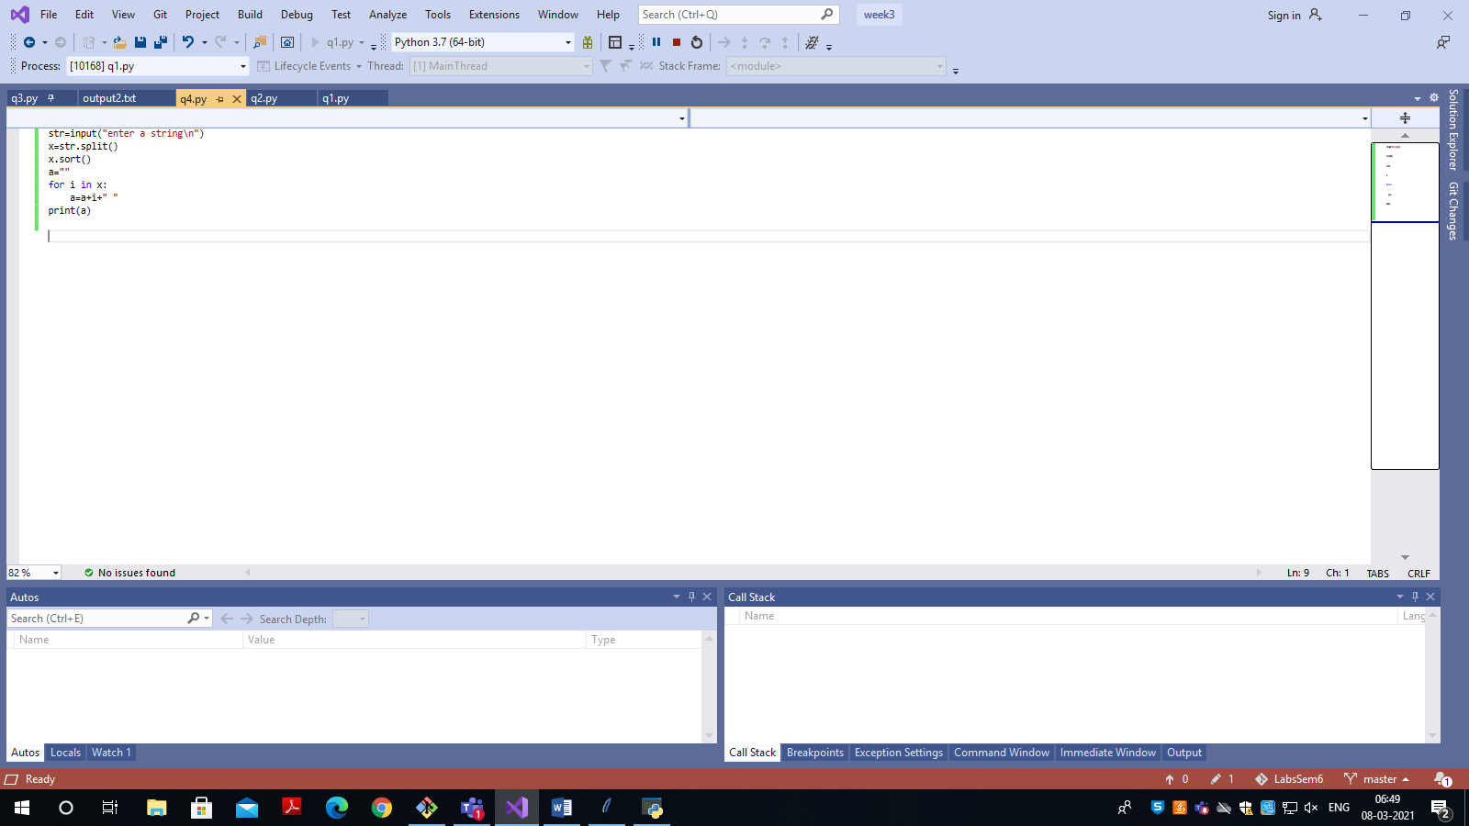 reversed: 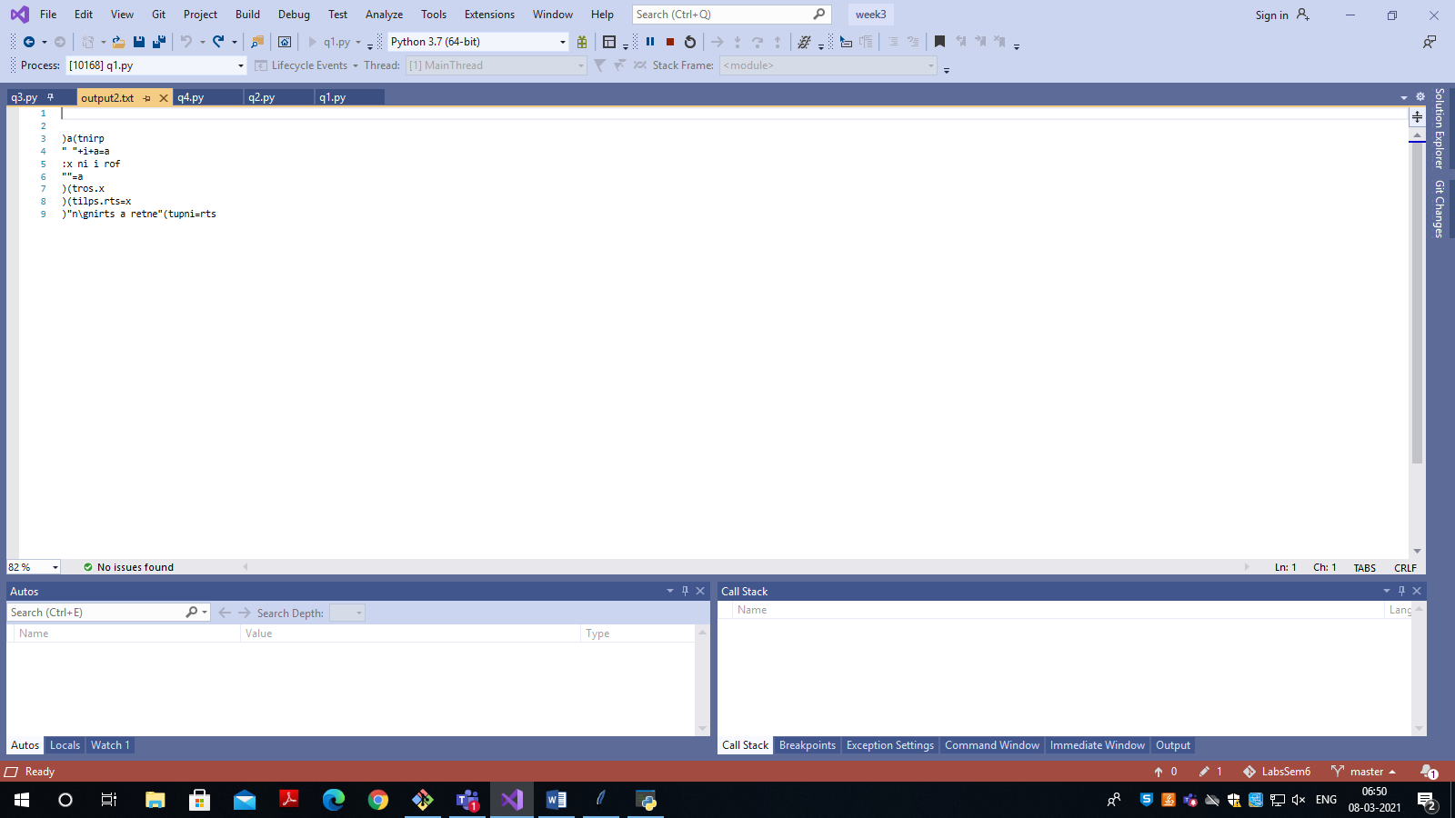

Q3) def bsearch(l,u,f):

if(l>u):

print("not found")

else:

mid=int((l+u)/2)

if(x[mid]==f):

print("found elemnt",f,"at pos",mid+1)

elif(x[mid]>f):

bsearch(mid,u,f)

else:

bsearch(l,mid,f)

x=[]

y=int(input("enter number of elements\n"))

print("enter ",y,"elements\n")

for i in range(0,y):

x.append(int(input()))

x.sort()

print(x)

s=int(input("enter the search elemnt\n"))

a=0

bsearch(0,y-1,s)

output:

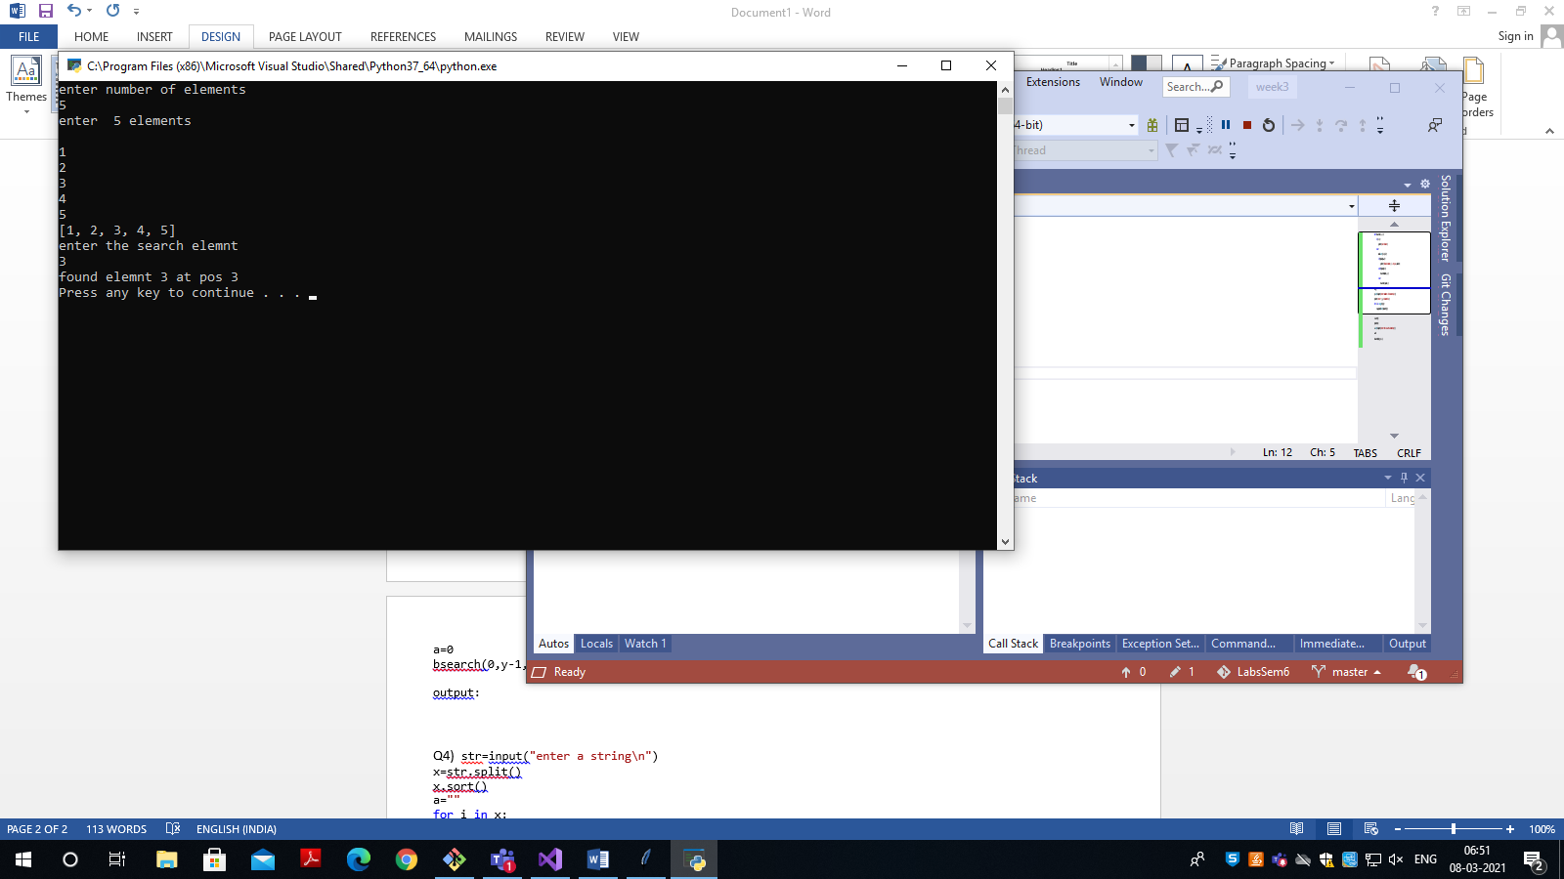

Q4) str=input("enter a string\n")

x=str.split()

x.sort()

a=""

for i in x:

a=a+i+" "

print("reversed string is:\n",a)

output:

